An Information Based Sequence Distance and Its Application to Whole Mitochondrial Genome Phylogeny
Ming Li, Jonathan H. Badger, Xin Chen, Sam Kwong, Paul Kearney, and Haoyong Zhang
- Introduction
- Methods
For a function d to be a “distance”, it must satisfy
- 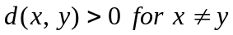
- 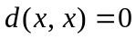
Definition: 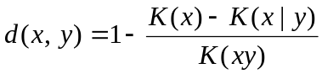
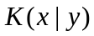 is defined as the length of the shortest program causing a standard universal computer to output x on input y.
Approximate : GenCompress
- Results
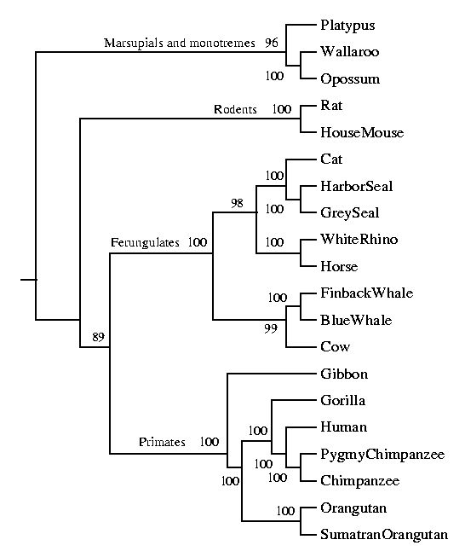
Created by: Chia-Mao Huang
Date: Jan. 1, 2001

